Project 3 Proposal

## Group Members

* Catherine Tratnik
* Manisha Lal
* Myfanwy Brown-Robinson
* Rubalpreet Bhullar
* Sharanvika Jegatheeswaran

## Topic of Interest:

* Bike share program in Toronto, Vancouver, Boston, NYC in 2019

## Links:

* [Git Hub Repository](https://github.com/myfanwybr/project3)
* [Brain Storm file](https://drive.google.com/drive/folders/1ccfX_yrhQqhR2D9Vdrh2SfJNaYfZQW1B?usp=sharing)

## Brief Articulation:

As the Ministry of Transportation Canada, we aim to further develop infrastructure in our country that helps promote sustainability, economical development and promote a healthy lifestyle with our populace. To establish such infrastructure, we base our study on the feasibility of implementing a bike share program across Canada. We use comparative data from two major cities from Canada and USA, that already have a bike-sharing program implemented and are active in gathering insight on bike-sharing programs.

## Our Dataset

NOTE: Will be queried from data base. Data base change required to accommodate for data record storage. Solution use Big Query and have the system take on the heavy workload.

* City Trip Data
  + [Toronto](https://open.toronto.ca/dataset/bike-share-toronto-ridership-data/)
  + [Vancouver](https://www.mobibikes.ca/en/system-data)
  + [Boston](https://www.bluebikes.com/system-data)
  + [NYC](https://www.citibikenyc.com/system-data)
* Station Details Data
  + [Toronto](https://toronto-us.publicbikesystem.net/ube/gbfs/v1/en/station_information)
  + [Vancouver](https://vancouver-gbfs.smoove.pro/gbfs/en/station_information.json)
  + [Boston](https://gbfs.bluebikes.com/gbfs/en/station_information.json)
  + [NYC](https://gbfs.citibikenyc.com/gbfs/en/station_information.json)
* [Historical Weather Data](https://www.worldweatheronline.com/developer/api/historical-weather-api.aspx)
* Pricing Data
  + [Toronto](https://bikesharetoronto.com/pricing/)
  + [Vancouver](https://www.mobibikes.ca/en/offers-subscription)
  + [Boston](https://www.bluebikes.com/pricing)
  + [NYC](https://www.citibikenyc.com/pricing)

## Sketching Visual Ideals

* Visualizations to use: [city route drawing]

1. Bar Chart that looks at total trip’s vs month vs temperature
   1. X = dates
   2. Y = number of trips
   3. Bar colour reflect thermal state.
2. Bar chart that looks at popular stations
   1. X = stations
   2. Y = number of trips
3. Bubble chart that looks at the popular time of day
   1. X = time intervals
   2. Y = number of trips (radius)
4. Gauge chart looks at the avg distance and duration [on average in a year]
5. Leaflet [apply city map] that looks at the travel route with bike in a city.

## Tasks:

1. Big Query transform & load data to query information.
2. Python
   1. Flask [app.py]
   2. Routes
      1. Home
      2. Pricing Index
      3. Weather Info
      4. Visualizations (all cities)
      5. Interactive page (city map)
3. Html
   1. Index.html
   2. Style.css
   3. Form.html
      1. Dropdown
      2. Text box
      3. Menu bar
4. Java script [access from localhost]
   1. App.js [visualizations]
   2. NOTES: the below will counter the time it takes to load data
      1. Should have the lightest amount of workload.
      2. Should just grab information.
      3. No processing
      4. Do not use JS to run data.
5. Heroku

* Sketch of tasks

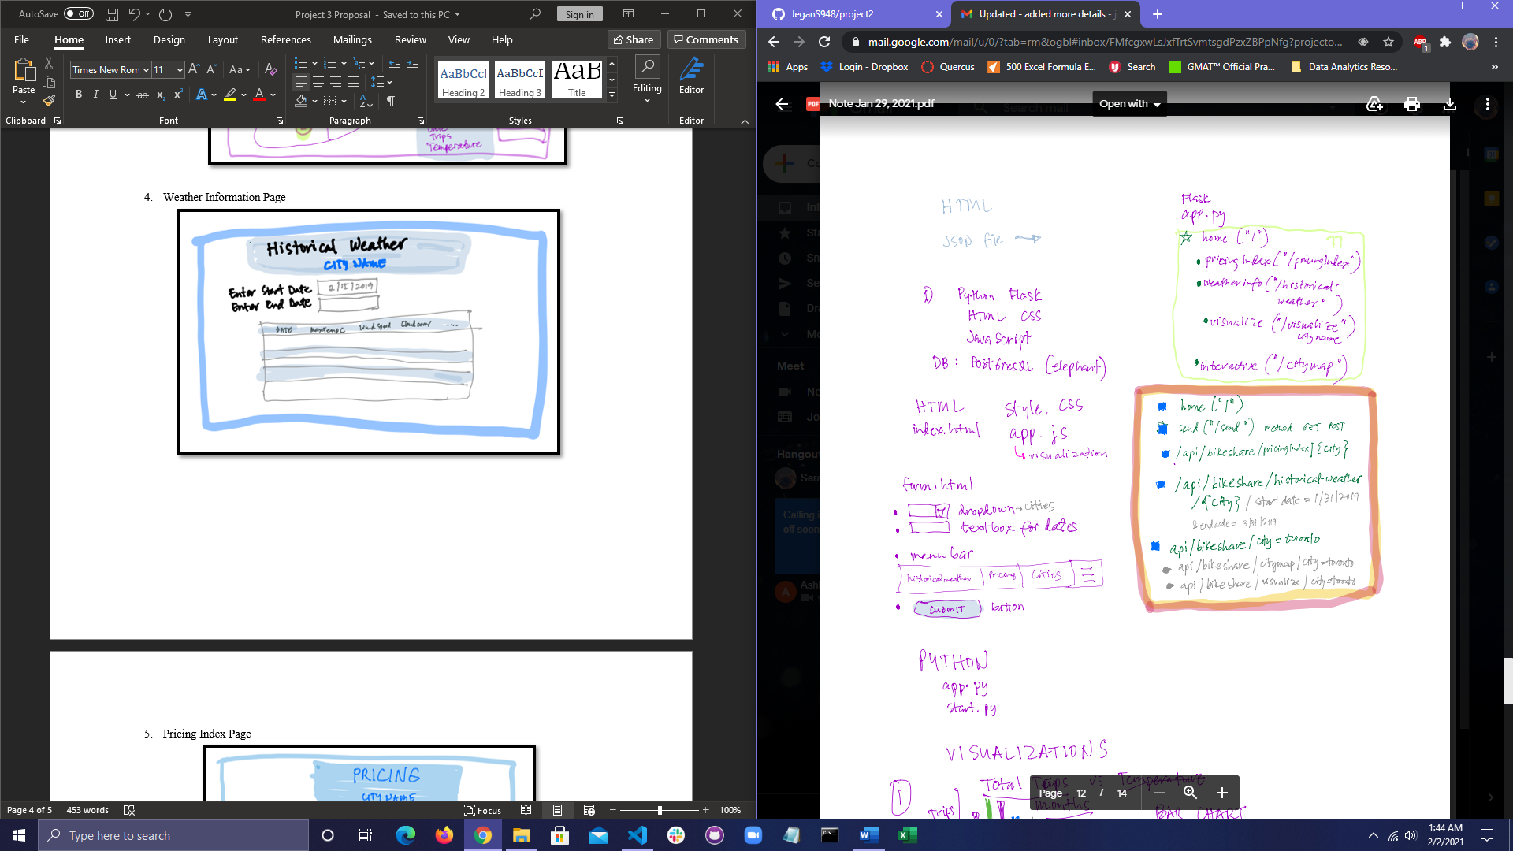

## Web Page Template:

1. Homepage

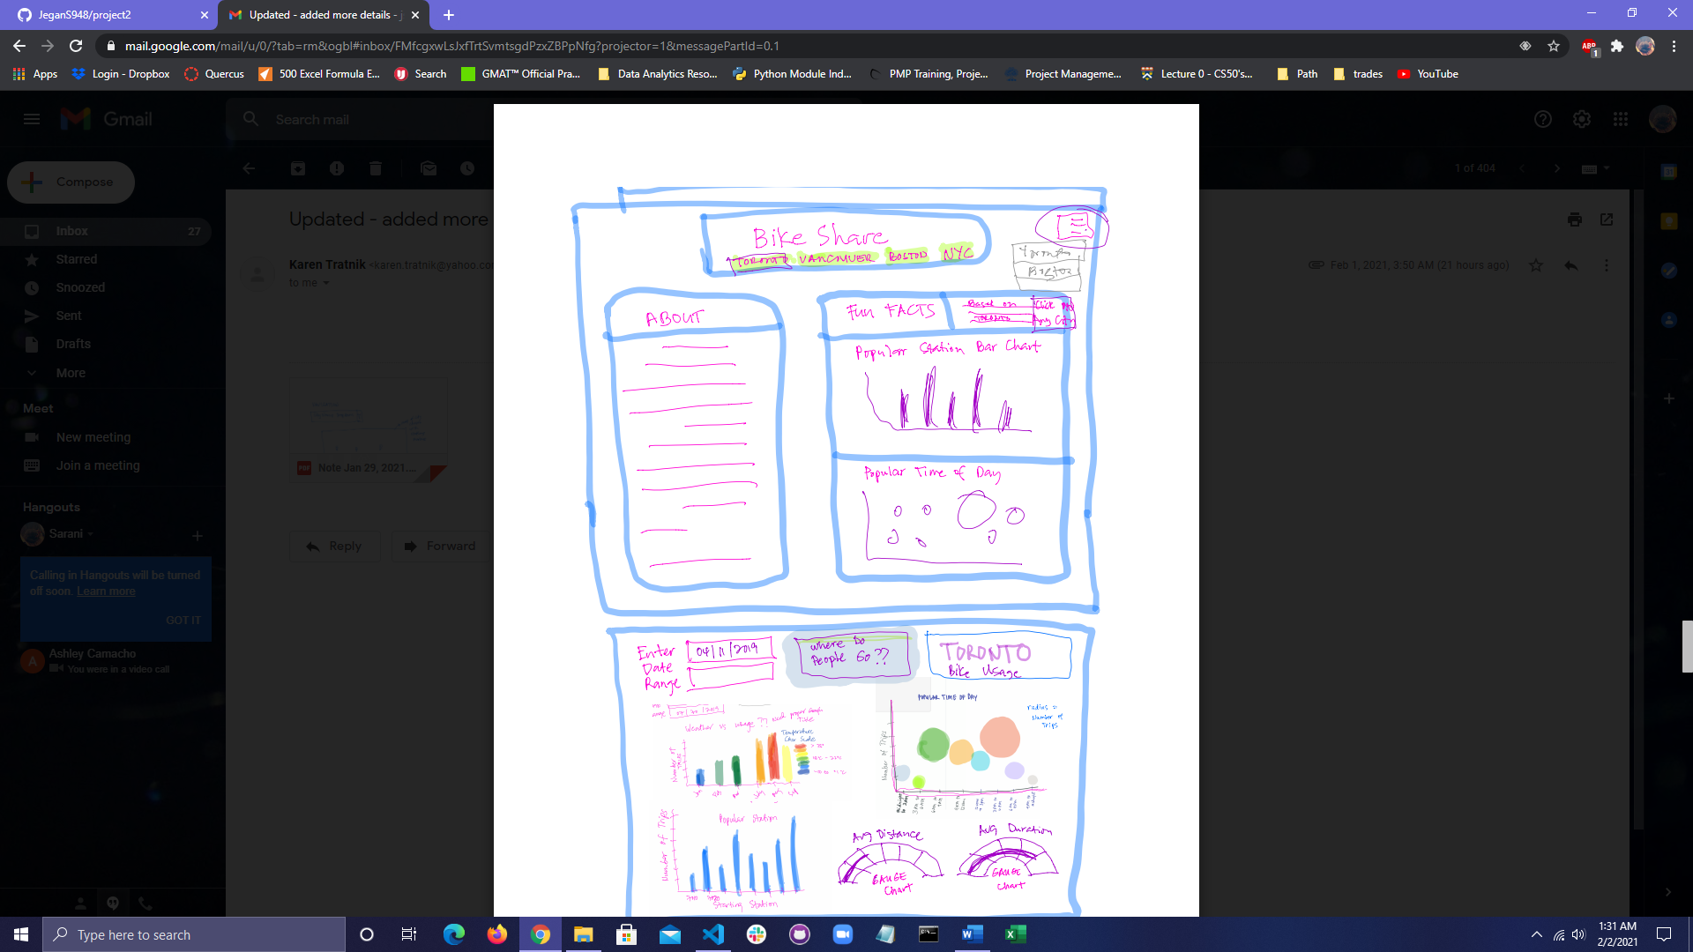

1. City Route Page

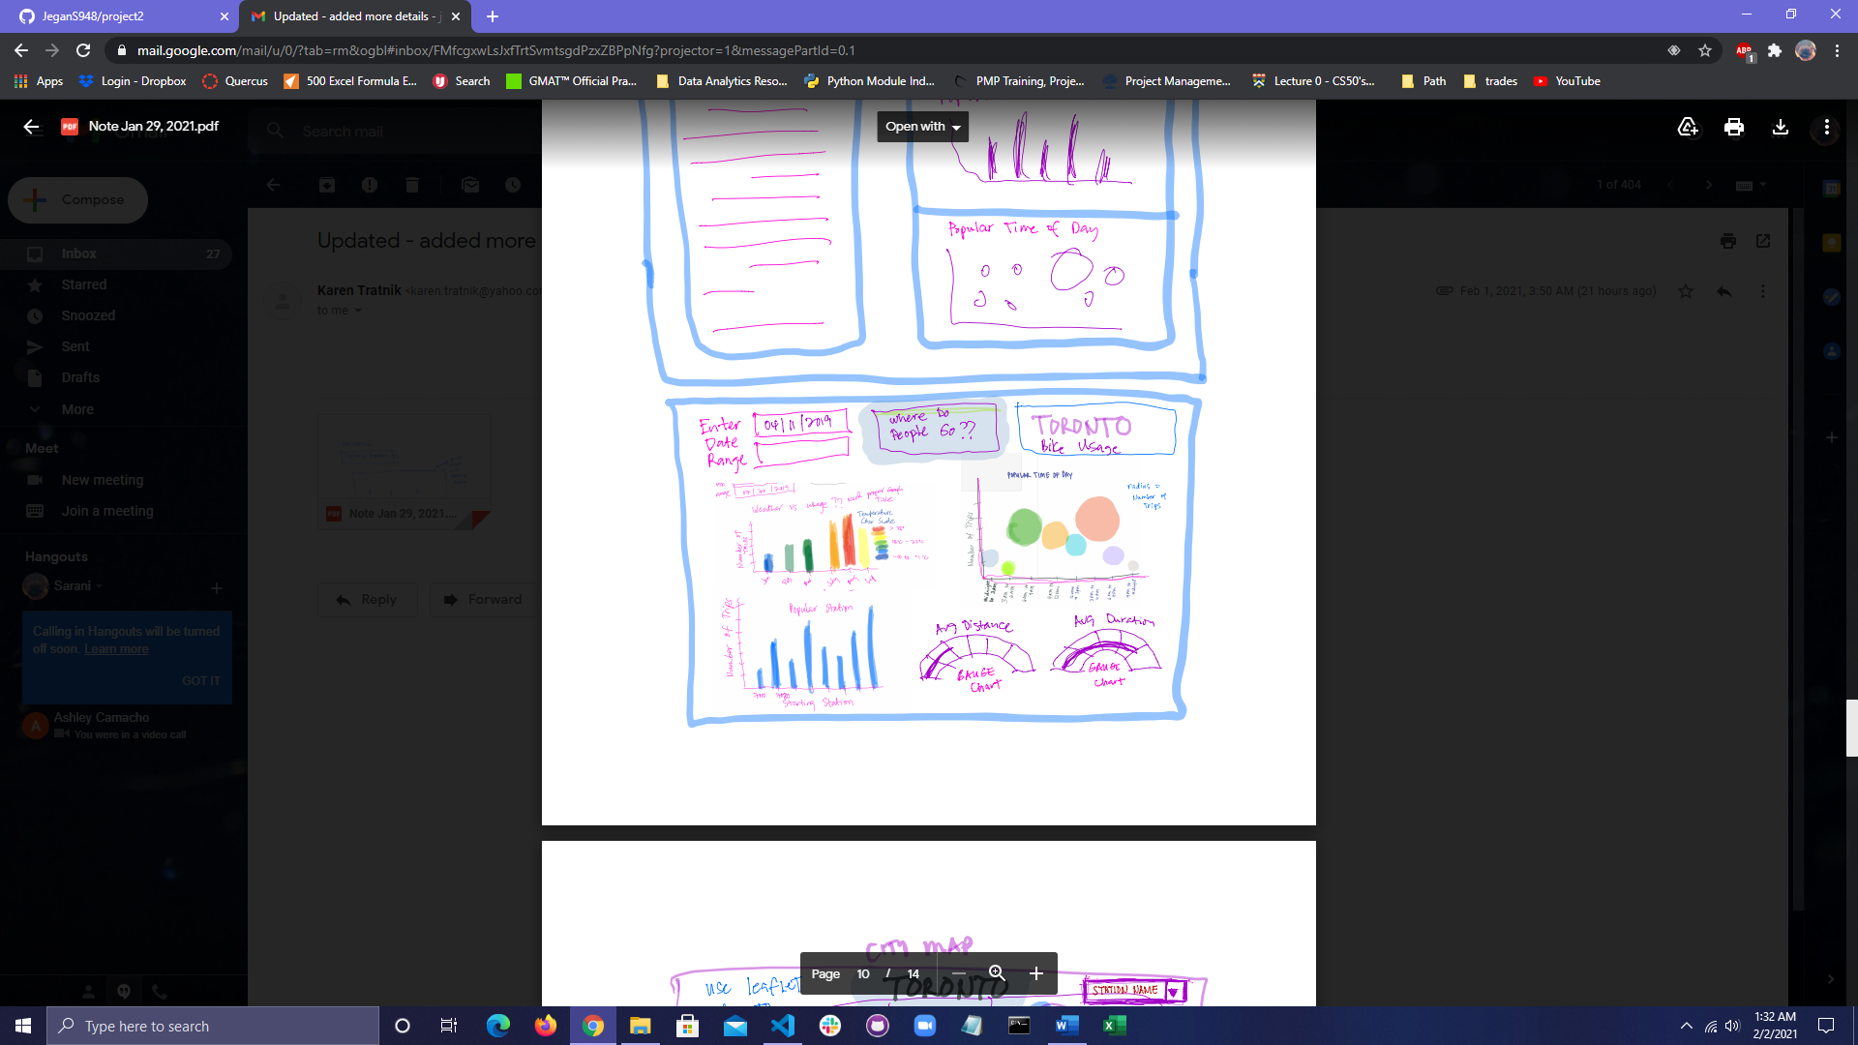

1. Interactive Page

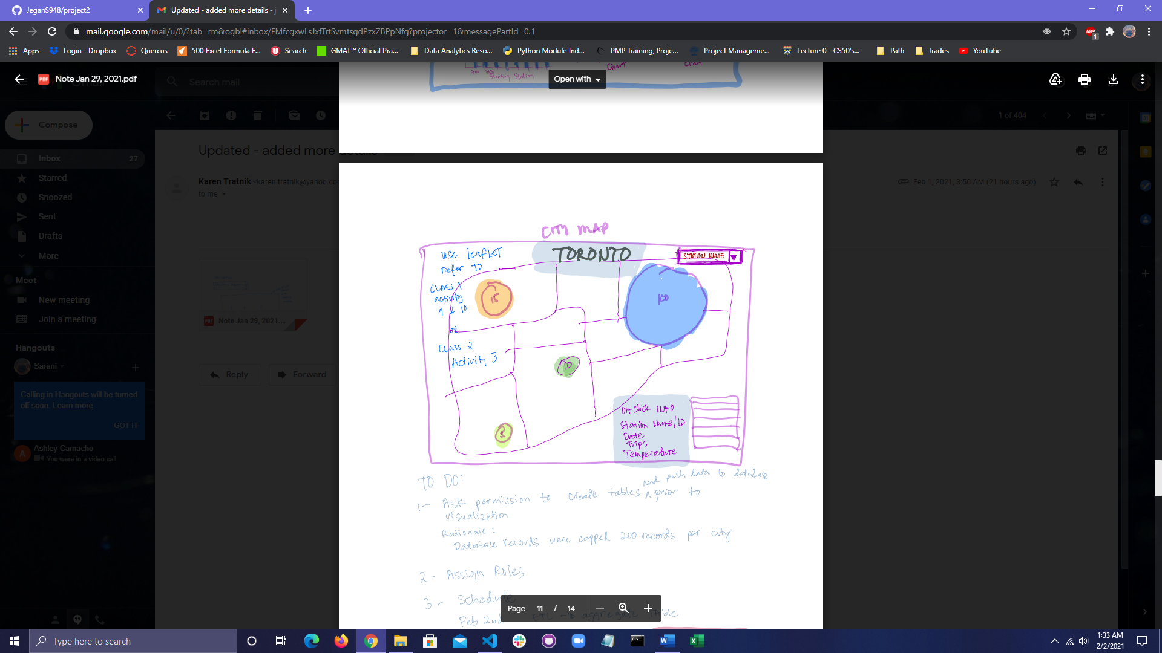

1. Weather Information Page

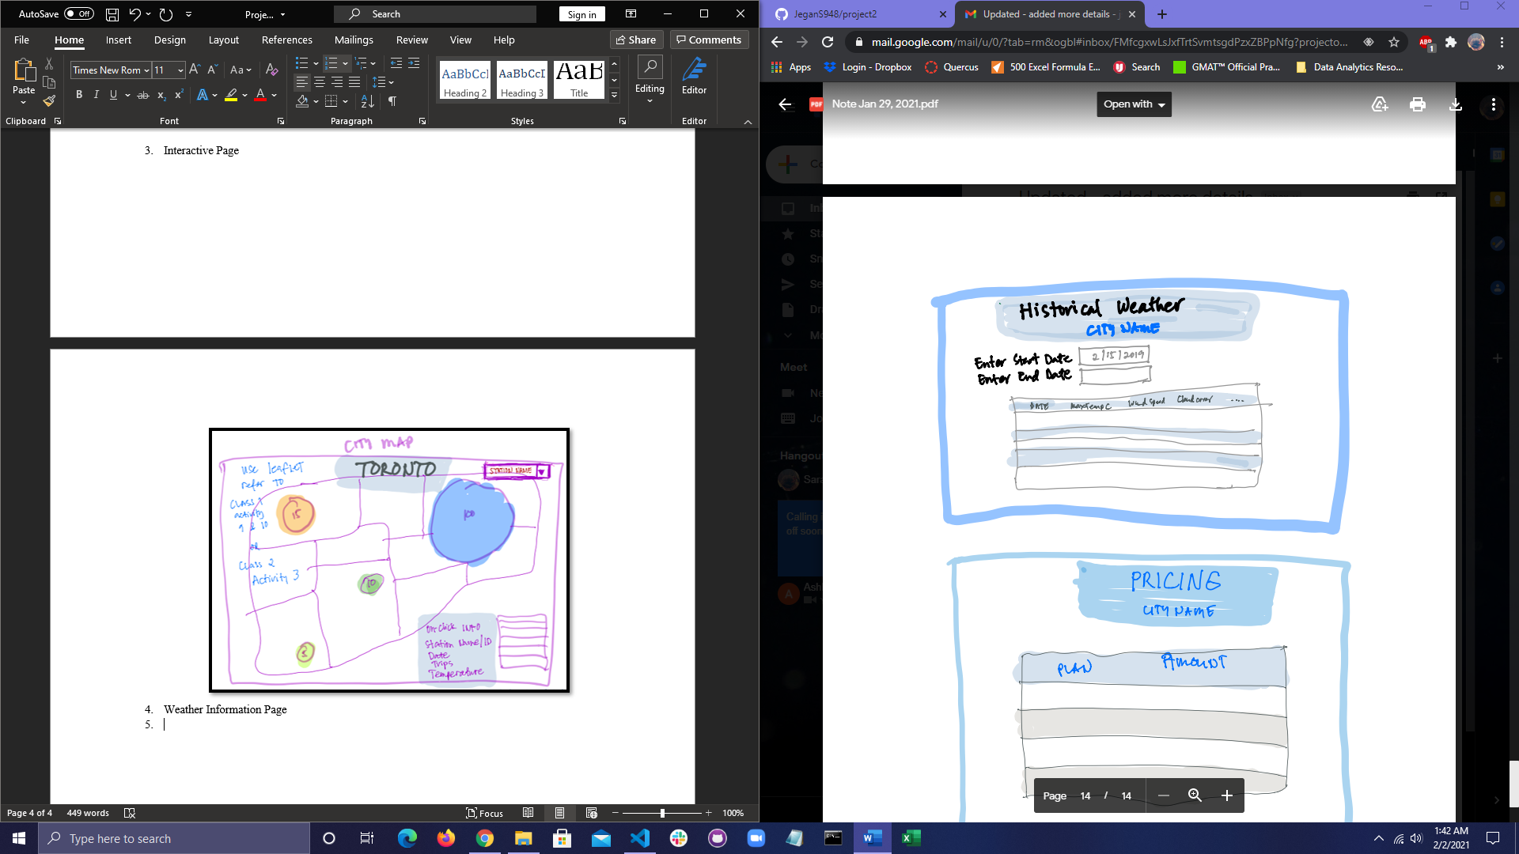

1. Pricing Index Page

